**First Step Data Ingestion**

From - SQL SERVER DB

TO – ADLS

Pipeline – ADF

Step 1:

Let’s first create Azure SQL Database with Server:

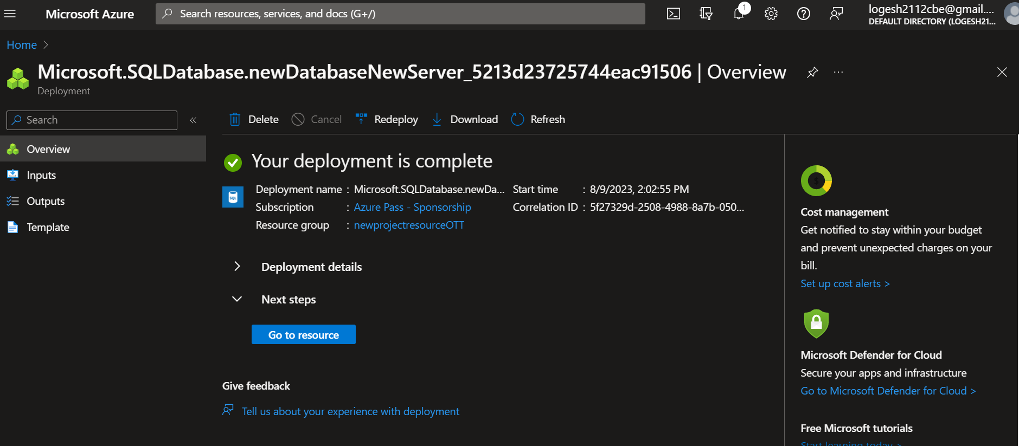

Step 2:

Launching the Azure SQL DB and Creating a Database:

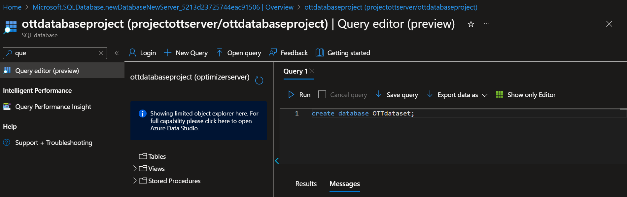

Step 3:

Let’s connect to SQL database

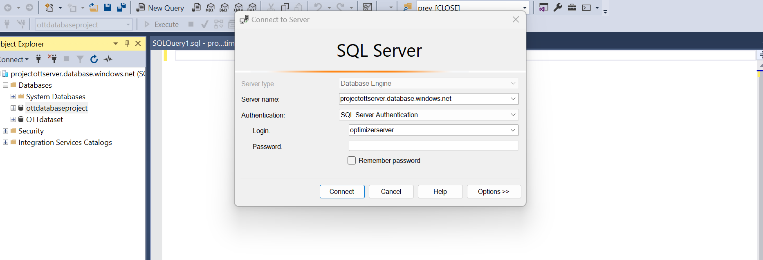

Step 4:

Let’s send a particular database to Azure SQL DB

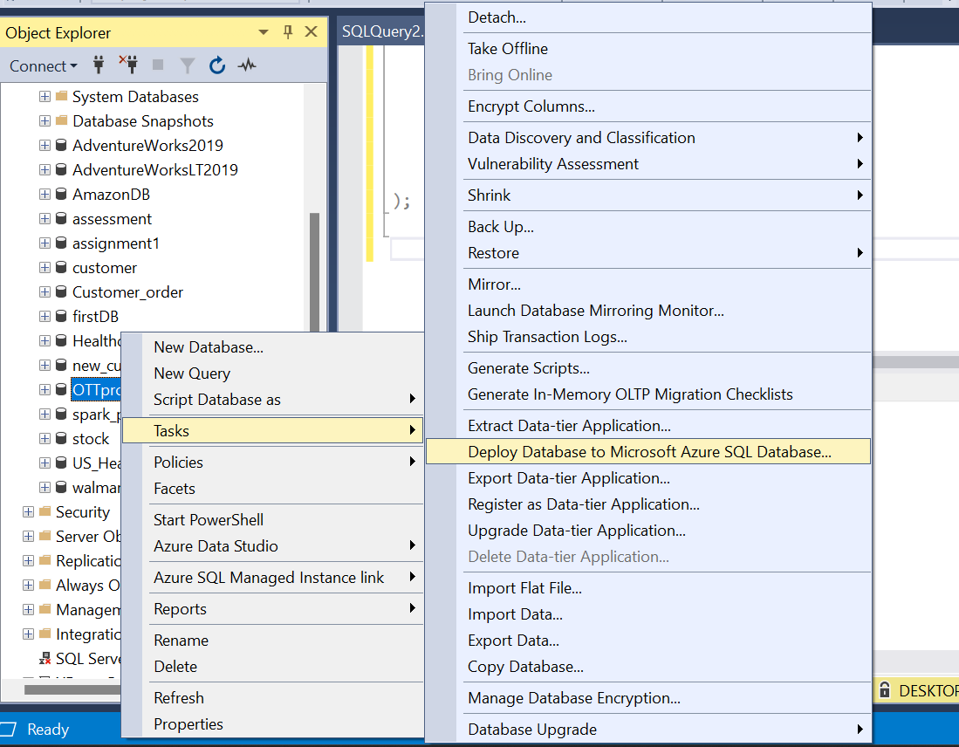

Let’s Send the data to the Azure SQL DB, & in last we have received the data in the Azure DB

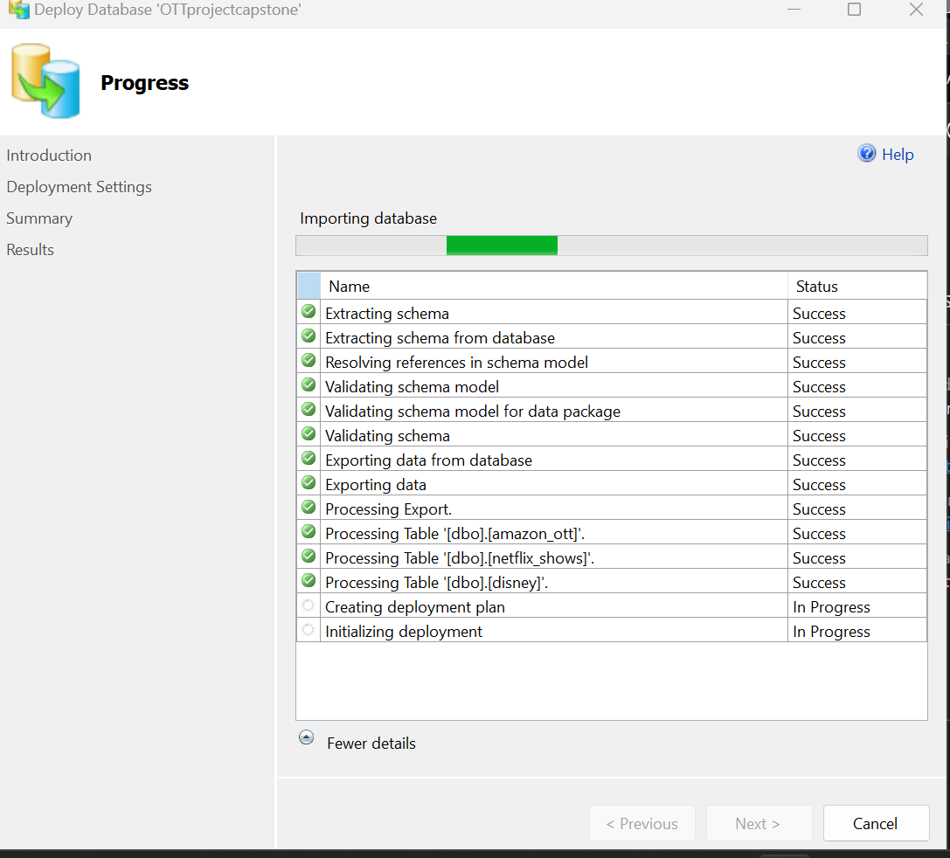 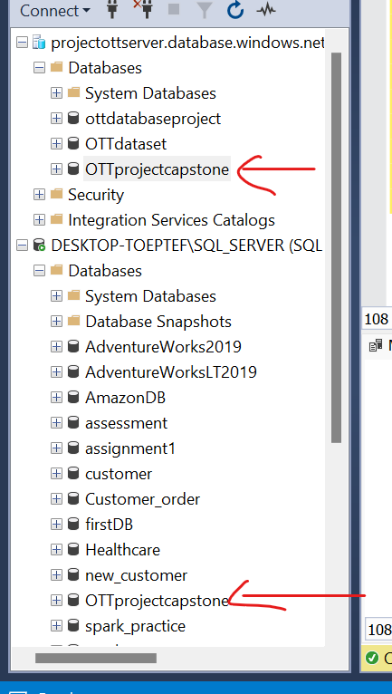

Step 5: Let’s create a ADF pipeline to get the data into the ADLS from AZURE ADF

Let’s first create a container in the ADLS: This is our destination

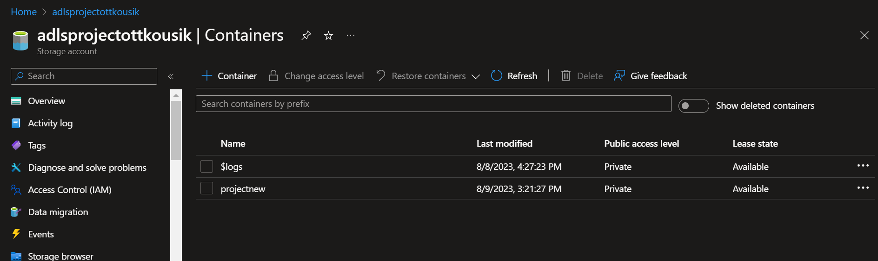

Step 6:

Data is in Azure SQL DB, This is our source

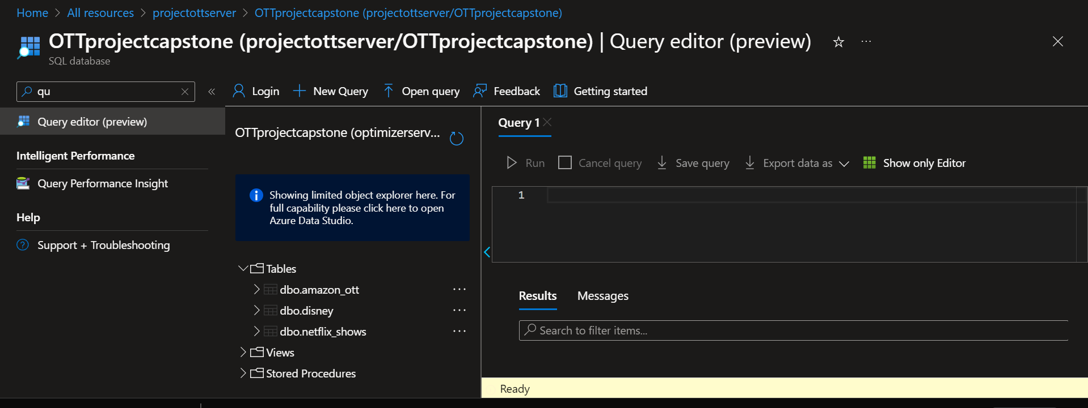

Step 7:

Creating ADF Pipeline to transfer data from Azure SQL DB to ADLS.

Go to Managed in ADF, create 2 linked service.

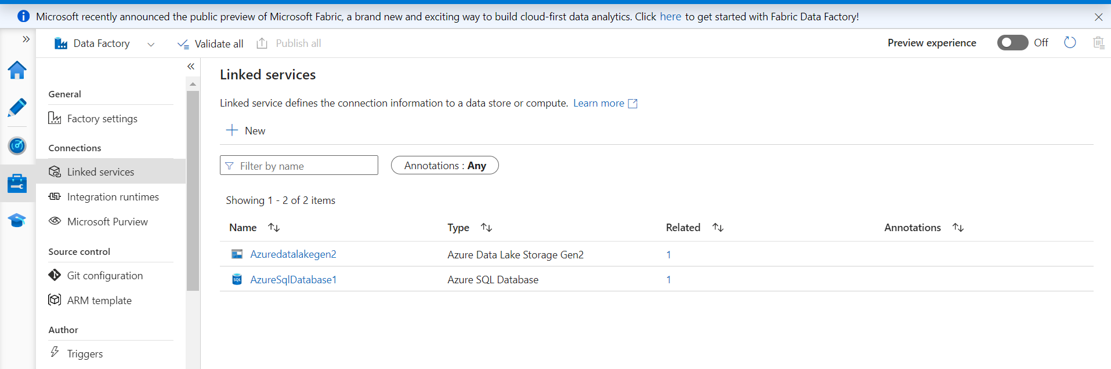

Next, go to author and create two datasets:

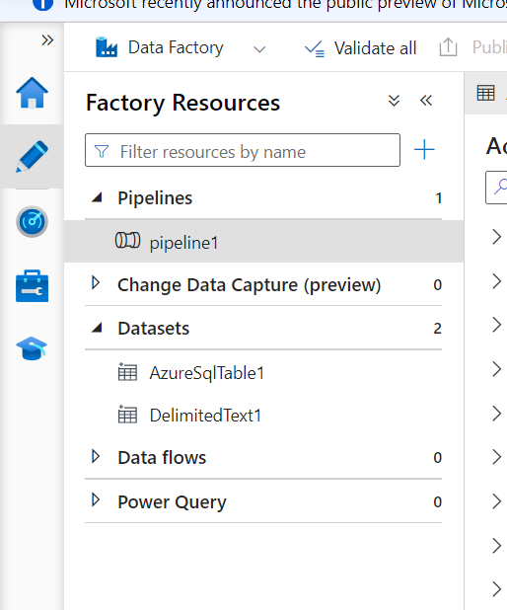

Next create a foreach activity:

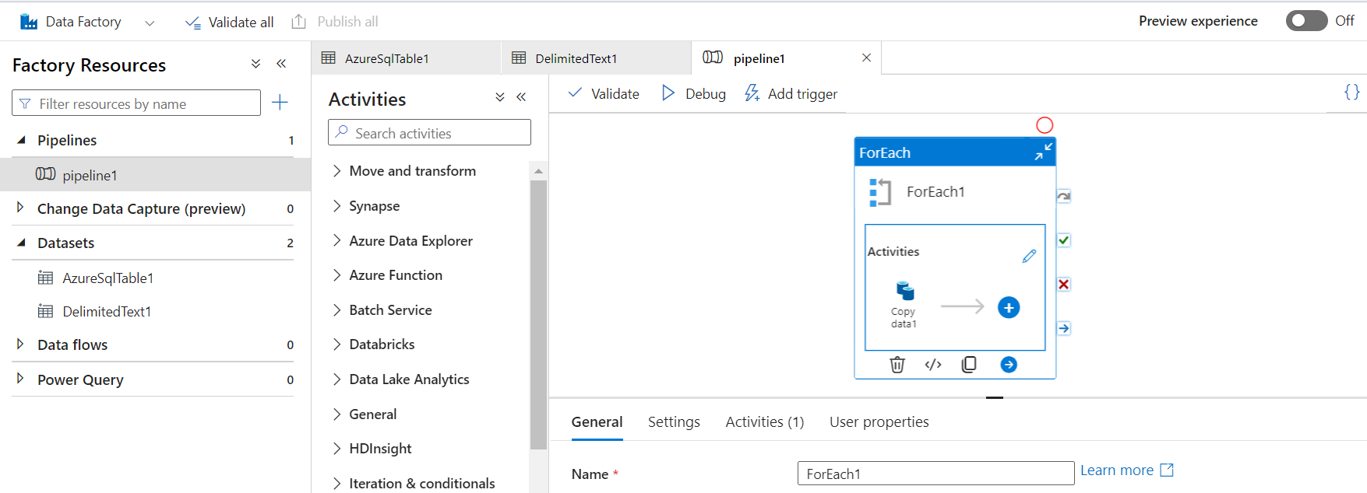

**Pipeline:**

